User Guide

jWebSocket
C# Client Library
Version 1.0

Version control
Date | Version | Description | Author
05/17/12 | 1.0 | Document Create | Rolando Betancourt Toucet

- Characteristics of the solution

The client library for developing applications with the framework jWebSocket using the programming language C #, is just a set of classes and functions that provide a well-defined interface and structured to manage communication between a client application and the framework jWebSocket work. It is useful for the community of developers using the programming language C #, because using this library can focus on application logic without losing time in the protocol implementation WebSocket to achieve communication with the framework.

- Main features

The main functional client library has to develop applications with the framework jWebSocket using the C # programming language in version 1.0 include:

- Allow the connection to the framework jWebSocket: This feature allows the connection between an application developed with the programming language C # and the framework jWebSocket.

- Allow send token of type text into the framework jWebSocket: This feature allows you to send information from the client application to the framework jWebSocket using an abstract data structure called a token, and type of data you can send is text or a string in base64.

- Allow binary token sent to the framework jWebSocket: This feature allows you to send information from the client application to the framework jWebSocket using an abstract data structure called a token, and type of data you can send is binary, a string of bytes.

- Allow fragmented send token to the framework jWebSocket: This feature allows you to send information from the client application to the framework jWebSocket using the abstract data structure token. When this information is greater than the maximum size allowed by the server then sends the token into small fragments which are then assembled on the server.

- Allow incoming receive and interpret token from the server jWebSocket: This feature allows you to receive information from the server to pack jWebSocket and process using the abstract data type token. In this format is that it will give you the information to the client application that uses this library.
- Allow fragments Receive and interpret incoming token from the server jWebSocket: This feature allows you to receive information from the server to pack jWebSocket and process using the abstract data type token. When this information is fragmented, then uses a powerful algorithm to assemble and then offer it to the client application that uses this library.
- Allow Close the connection to the framework jWebSocket: This feature is in charge of sending a token with the closing information jWebSocket framework, which will respond to that request and suspend the connection.

- Problems to resolve

Problem | Contributions of the solution
Improve productivity and reliability of real-time applications with the programming language C # using the framework of jWebSocket | A library that allows the integration of client applications using the programming language C # with the framework jWebSocekt.

- Glossary
Web in real time: It is possible when the client receives messages from the server without prior request and end users to receive updates at the same time.
Client library: An application programming interface (API) used to write client applications. Provides building blocks generic for building client applications
JWebSocket framework: A new technology aimed at developing Web Sockets based applications that provide high levels of speed, scalability, security and work in real time.
WebSocket: A technology that provides a bidirectional communication channel and full-duplex over a single TCP socket. This protocol solves the limitations of HTTP, by establishing a full-duplex communication (TCP) between the client and server, replacing the half-duplex communication (HTTP).
Full-Duplex: Quality of the elements that allow the input and output simultaneously.
Half-duplex: Method or protocol for sending information but not simultaneous bidirectional.

- Model of the solution
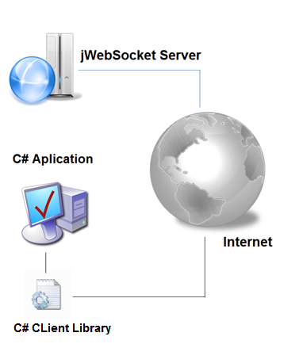
Picture 1: Model of the solution

- Use Requirements
There must be an operating system Windows XP or any later version. You must have Visual Studio 2005 IDE or any later version.

- Roles of solution

System User: It is able to utilize the functionality of the system.

